Cod soft Internship Task-

Q.1

Program-

package Com.basics.Practice;

import java.util.Scanner;

public class AtmMachine {

private BankAccount bankAccount;

public AtmMachine(BankAccount bankAccount) {

this.bankAccount = bankAccount;

}

public void showMenu() {

System.***out***.println("CodSoft Task 3:- ATM Interface By Sayali God");

System.***out***.println("ATM Menu:");

System.***out***.println("1. Check Balance");

System.***out***.println("2. Deposit");

System.***out***.println("3. Withdraw");

System.***out***.println("4. Exit");

}

public void run() {

try (Scanner scanner = new Scanner(System.***in***)) {

int choice;

do {

showMenu();

System.***out***.print("Enter your choice: ");

choice = scanner.nextInt();

switch (choice) {

case 1:

System.***out***.println("Your Balance: $" + bankAccount.getBalance());

break;

case 2:

System.***out***.print("Enter deposit amount: $");

double depositAmount = scanner.nextDouble();

bankAccount.deposit(depositAmount);

break;

case 3:

System.***out***.print("Enter withdrawal amount: $");

double withdrawalAmount = scanner.nextDouble();

bankAccount.withdraw(withdrawalAmount);

break;

case 4:

System.***out***.println("Exiting the ATM. Have a nice day!");

break;

default:

System.***out***.println("Invalid choice. Please select a valid option.");

}

} while (choice != 4);

}

}

public static void main(String[] args) {

BankAccount account = new BankAccount(1000);

AtmMachine atm = new AtmMachine(account);

atm.run();

}

}

class BankAccount {

private double balance;

public BankAccount(double balance) {

this.balance = balance;

}

public double getBalance() {

return balance;

}

public void deposit(double amount) {

balance += amount;

System.***out***.println("$" + amount + " deposited successfully.");

}

public void withdraw(double amount) {

if (amount > balance) {

System.***out***.println("Insufficient balance. Withdrawal failed.");

} else {

balance -= amount;

System.***out***.println("$" + amount + " withdrawn successfully.");

}

}

}

OutPut-

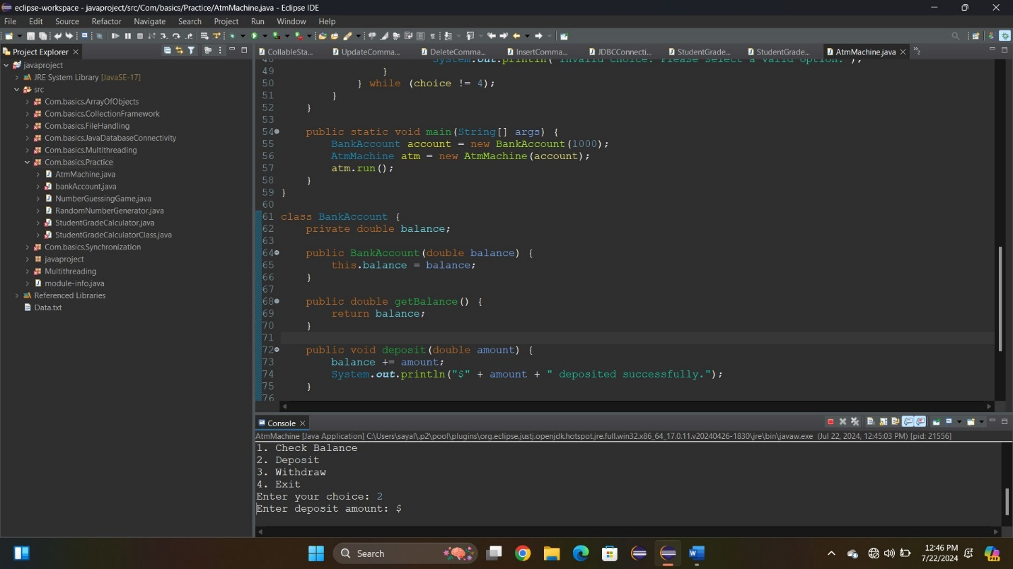

Q.2-

Program-

package Com.basics.Practice;

import java.util.Random;

import java.util.Scanner;

public class NumberGuessingGame {

public static void main(String[] args) {

Scanner sc = new Scanner(System.in);

Random random = new Random();

boolean playGame = true;

System.out.println("Welcome to the Number Guessing Game!");

while (playGame) {

int secretNumber = random.nextInt(100) + 1;

int attempts = 0;

System.out.println("I'm thinking of a number between 1 to 100.");

while (true) {

System.out.print("Your guess: ");

int userGuess = sc.nextInt();

attempts++;

if (userGuess == secretNumber) {

System.out.println("Congratulations! You guessed the number in " + attempts + " attempts.");

break;

} else if (userGuess < secretNumber) {

System.out.println("Try a higher number.");

} else {

System.out.println("Try a lower number.");

}

}

System.out.print("Do you want to play again? (yes/no): ");

String playAgain = sc.next().toLowerCase();

if (!playAgain.equals("yes")) {

System.out.println("Thanks for playing! See you soon.");

playGame = false;

}

}

sc.close();

}

}

Output-

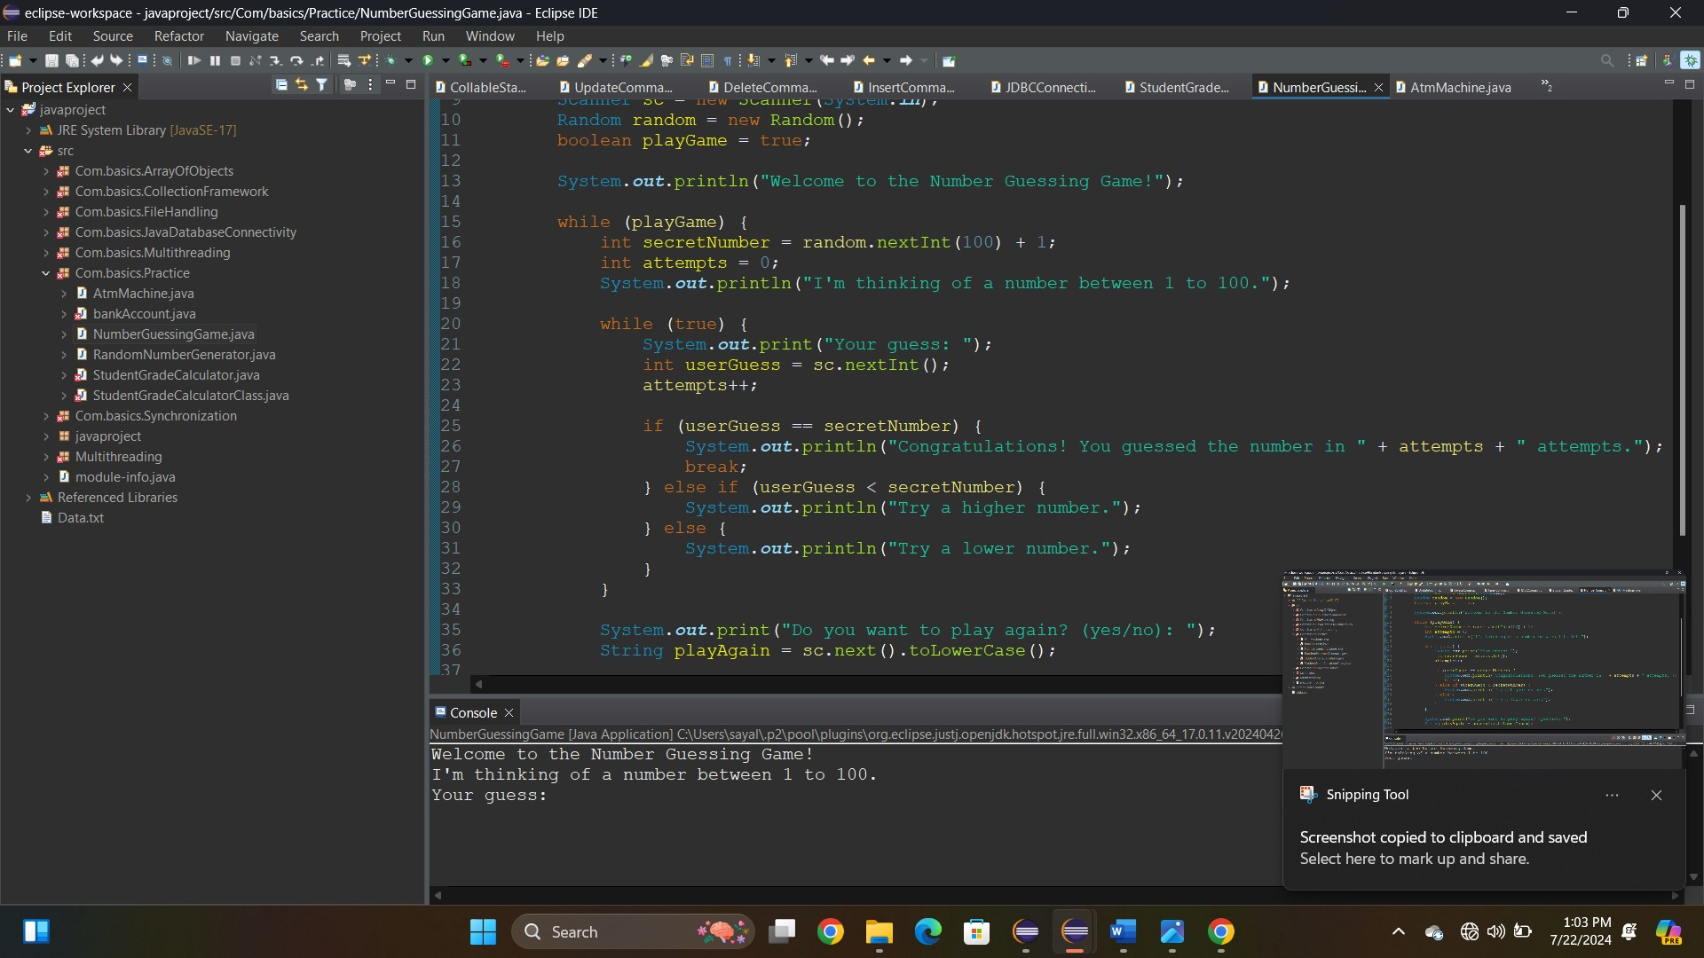

Q-3.

Program-

package Com.basics.Practice;

import java.util.Scanner;

public class StudentGradeCalculatorClass {

public static void main(String[] args) {

{

Scanner scanner=new Scanner(System.in);

System.out.println("Hello enter the number of subjects:");

int numSubjects=scanner.nextInt();

int[]marks=new int[numSubjects];

int totalmarks=0;

for(int i=0; i<numSubjects;i++)

{

System.out.println("Enter marks obtained in each subject"+(i+1)+":");

marks[i]=scanner.nextInt();

totalmarks +=marks[i];

}

double averagepercentage=(double)totalmarks/(numSubjects*100)*100;

System.out.println("Your Result is here:");

System.out.println("Your Total marks:"+totalmarks);

System.out.println("Average percentage:"+averagepercentage+"%");

int TotalMarks=0;

for(int i=0;i<=numSubjects;i++)

{

System.out.println("Enter marks obtained in each subject" +(i+1)+":");

marks[i]=scanner.nextInt();

totalmarks+=marks[i];

}

double averagePercentage=(double) totalmarks/(numSubjects*100)*100;

System.out.println("Your Result is here:");

System.out.println("Your total marks:"+totalmarks);

System.out.println("Average Percentage:"+averagepercentage+"%");

String Grade=CalculateGrade(averagePercentage);

System.out.println("Grade:"+Grade);

//Scanner.close();

}

//public static String CalculateGrade(double percentage)

{

if(percentage>=90)

{

return "A+";

}

else if(percentage>=80)

{

return "A";

}

else if(percentage>=70)

{

return "B";

}

else if(Percentage>=60)

{

return "C";

}

Object averageercentage;

String grade=calculateGrade(averageercentage);

System.out.println("Grade:"+grade);

Scanner scanner;

scanner.close();

}

String calculateGrade(double percentage)

{

if(percentage>=90)

return "A+";

}

else if

(percentage>=80)

{

return "A";

}

else if (percentage>=70)

{

return "B";

}

else if(percentage>=60)

{

return "c";

}

else if(percentage>=50)

{

return "D";

}

else

{

return "F";

}

}

}

OutPut-